

**Branch: CSE(AI&ML)**

**Team No: B3**

**Team Members:**

**R. Sanjay [218X1A4278] (Team Lead)**

**T. Akhila [218X1A42C5]**

**Sk. Bilal [218X1A4286]**

**T. Venkateswarlu [218X1A42C4]**

**Created by the team🧑🏻‍💻**

**project Document**

**INFORMATION OF THE TEAM:**

**Blissful Abodes : Scalable Hotel Booking Platform with Flask on AWS EC2 and RDS**

### Project Description:

The **Blissful Abodes** project develops a scalable hotel booking platform that enables seamless reservations for various room types, including Standard, Luxury, and Suites. Built with Flask for backend development and hosted on AWS EC2 with Amazon RDS for database management, this cloud-native solution ensures high availability and efficient user interactions. The platform simplifies room booking, customer management, and payment processing, showcasing a robust infrastructure tailored for the hospitality industry.

### Scenario 1: Scalable Web Applications for Hotel Booking

In scenarios involving hotel bookings, AWS EC2 provides a scalable infrastructure capable of handling high volumes of user traffic, such as during peak tourist seasons. For example, a hotel booking platform using EC2 can dynamically scale to accommodate increased booking requests during holiday seasons or promotional events, ensuring the website remains responsive. Flask is used for backend development to manage user sessions, room availability, pricing, and payment integration efficiently. This scalable architecture enables the platform to grow with user demand without compromising performance.

### Scenario 2: Efficient Database Management for Room Reservations

In a room booking platform, managing booking information, user details, room availability, and payment records is critical. Amazon RDS offers a managed MySQL database solution that simplifies operations, enabling automated backups, scaling, and high availability. For instance, RDS handles customer details, booking history, and room availability updates. By utilizing RDS for database management, the platform ensures consistent performance and data integrity as it scales to handle a growing user base and increased booking operations.

### Scenario 3: Secure and Scalable Hosting for Travel and Hospitality Platforms

In travel and hospitality applications, AWS EC2 provides a secure and scalable environment for hosting applications that manage customer bookings, room inventories, and guest requests. By integrating AWS IAM (Identity and Access Management) for access control, the platform ensures that only authorized users can access sensitive customer information and administrative controls. EC2’s ability to scale up or down based on demand ensures the booking platform can handle different levels of traffic efficiently, from regular day-to-day bookings to peak travel

TECHNICAL ARCHITECTURE

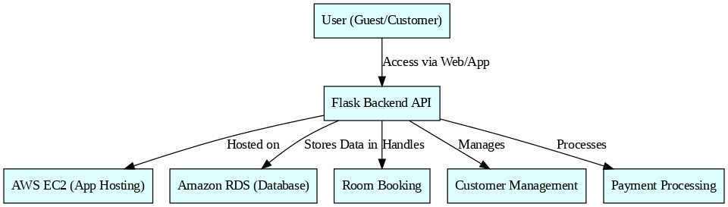

Entity Relationship (ER)Diagram

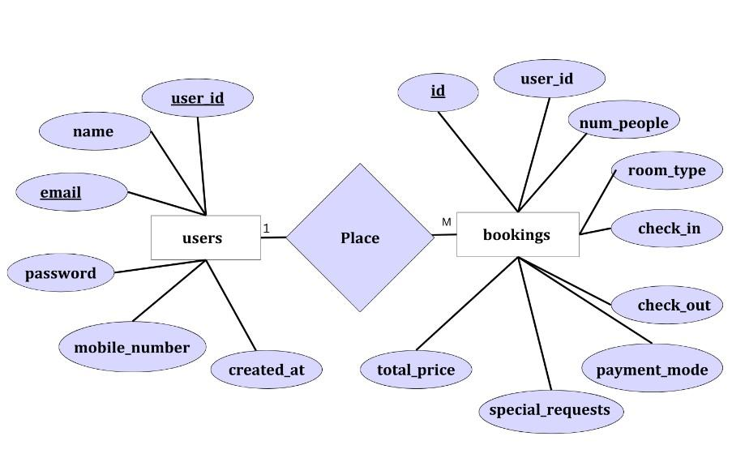

**Pre-requisites:**

### 1. AWS Account Setup: [https://youtu.be/CjKhQoYeR4Q?si=ui8Bvk_M4FfVM-D](https://youtu.be/CjKhQoYeR4Q?si=ui8Bvk_M4FfVM-Dh)h

### 2. Understanding of IAM: <https://youtu.be/gsgdAyGhV0o?si=3qg-bULgkD4LXNvR>

### 3. Knowledge of Amazon EC2 :<https://youtu.be/8TlukLu11Yo?si=MUj0nEAOESRhHUIz>

4. RDS : <https://www.youtube.com/live/MPau9c7PT74?si=A8OK-zFGbSKkAFWN>

5. MySQL WorkBench: <https://youtu.be/wALCw0F8e9M?si=ovMF9qMx5rLxaznB>

### Project Flow:

1. **AWS Account Setup and Login**
   * Set up an AWS account if not already done.
   * Log in to the AWS Management Console to manage resources.
2. **RDS Database Creation and Setup**
   * **Activity 2.1**: Create an RDS Instance.
     + Navigate to RDS service in the AWS Console and configure your database instance (select MySQL).
   * **Activity 2.2**: Install MySQL Workbench.
     + Download and install MySQL Workbench on your local machine.
     + Use the endpoint and credentials of your RDS instance to establish a connection via MySQL Workbench.
3. **Frontend Development and Application Setup**
   * **Activity 3.1**: Build the Frontend.
     + Develop the frontend for the Blissful Abodes Hotel using HTML, CSS, and Flask (Python-based).
     + Ensure the structure supports the hotel’s booking functionality and user interaction.
4. **EC2 Instance Setup**
   * **Activity 4.1**: Launch EC2 Instance.
     + From the AWS Console, launch a Linux-based EC2 instance.
     + SSH into the instance and prepare the environment for hosting the application.
5. **Deployment on EC2**
   * **Activity 5.1**: Deploy to EC2.
     + Transfer the developed Flask application to the EC2 instance.
     + Install necessary dependencies (e.g., Flask, MySQL libraries) on EC2.
     + Configure the EC2 instance to connect to the RDS database.
     + Start the Flask application on the instance.
6. **Testing and Deployment**
   * **Activity 6.1**: Functional Testing.
     + Test the full application for functionality including frontend interaction, database communication, and overall performance.
     + Run the Flask app with python3 app.py and access the link provided to verify its correct functioning.
   * **Activity 6.2**: Deployment.
     + Finalize the deployment in the production environment.
     + Ensure high availability, security, and performance optimization.

**Milestone 1: AWS Account Setup and Login**

* **Activity 1.1: Create AWS Account**
  + Sign up for an AWS account and configure billing settings.

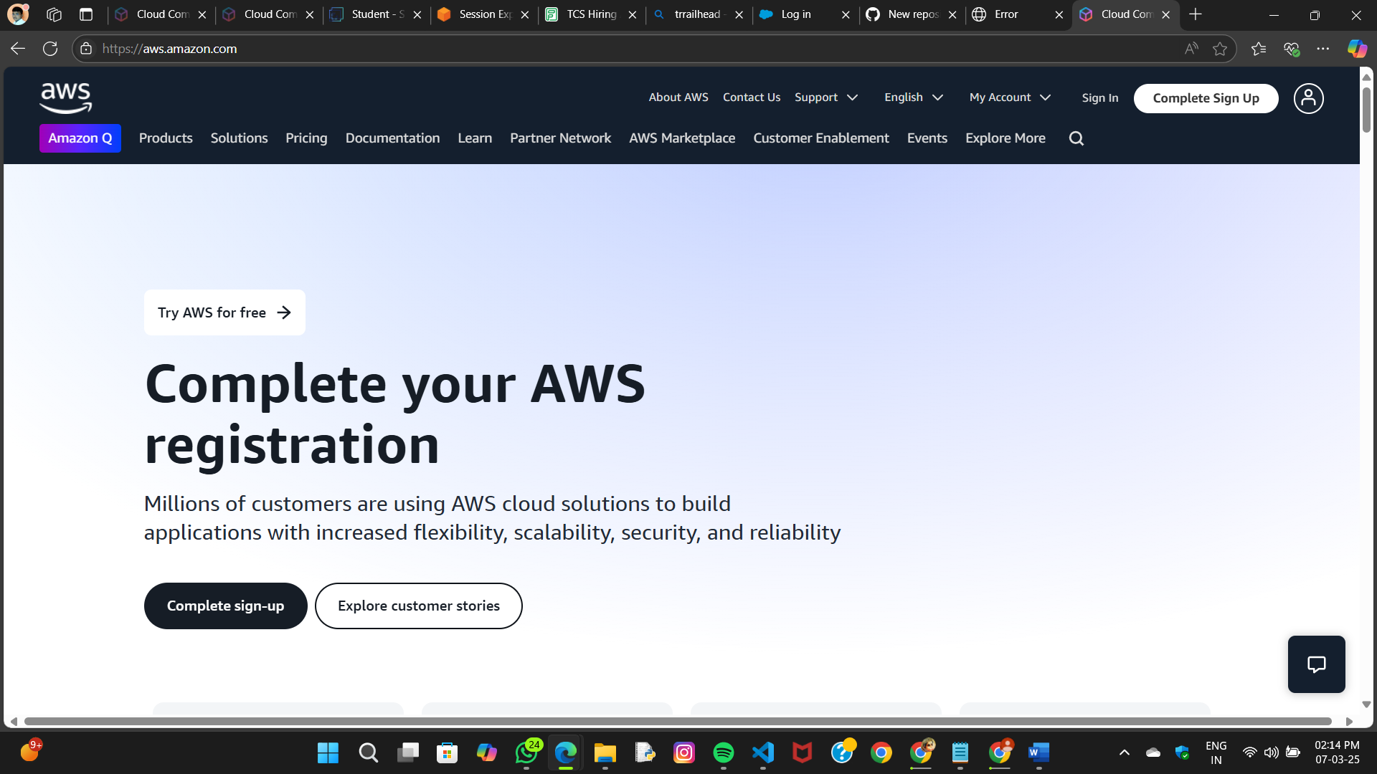

* **Activity 1.2: Login to AWS Management Console**
  + Access the AWS Management Console using your login credentials.

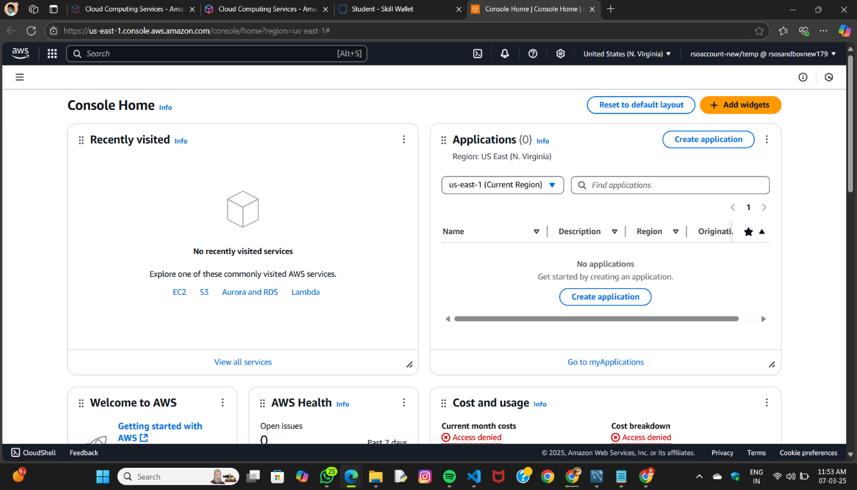

**Milestone 2: RDS Database Creation and Setup**

* **Activity 2.1: Create an RDS Instance**
  + Choose the RDS service from the AWS Management Console.

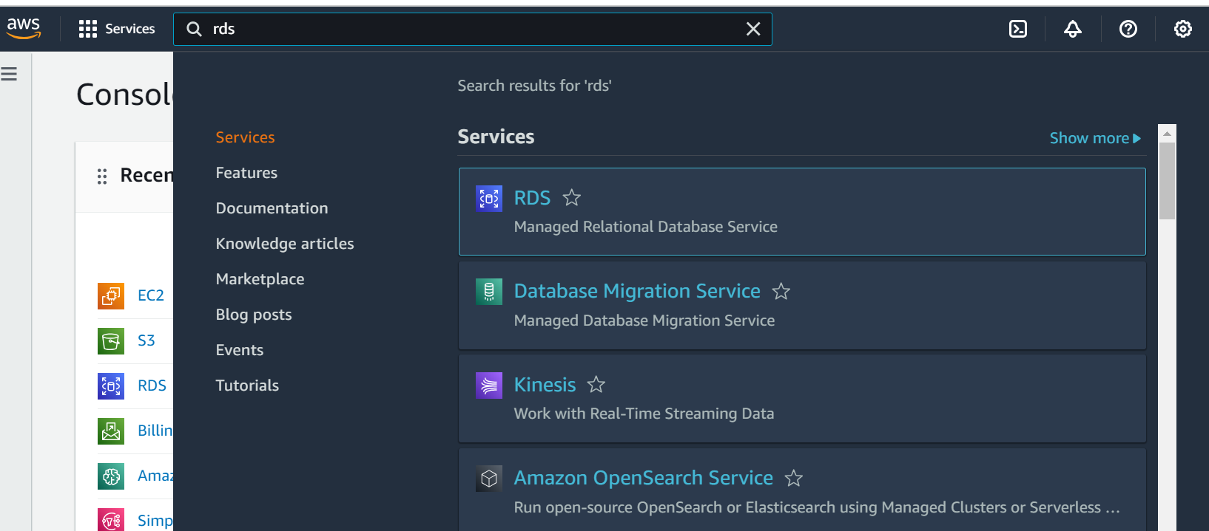

* + Select MySQL as the database engine, configure the instance settings (e.g., storage, instance class), and launch the RDS instance.

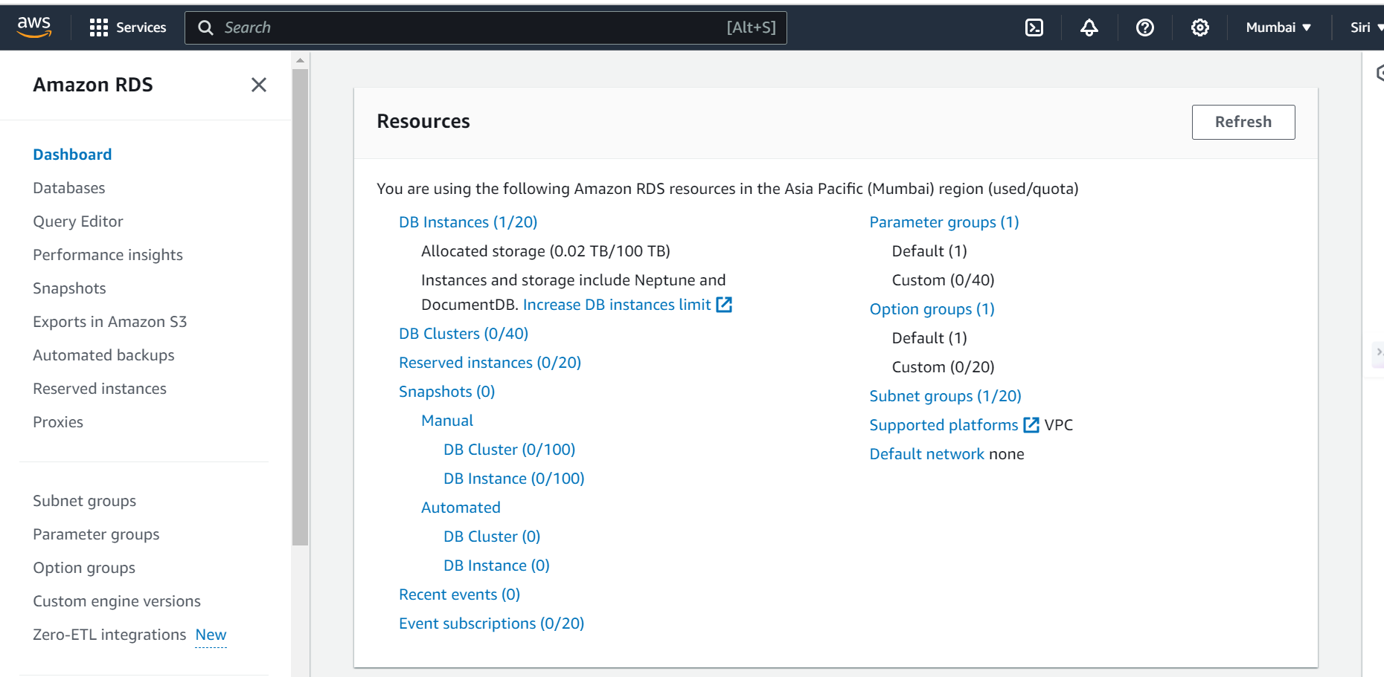

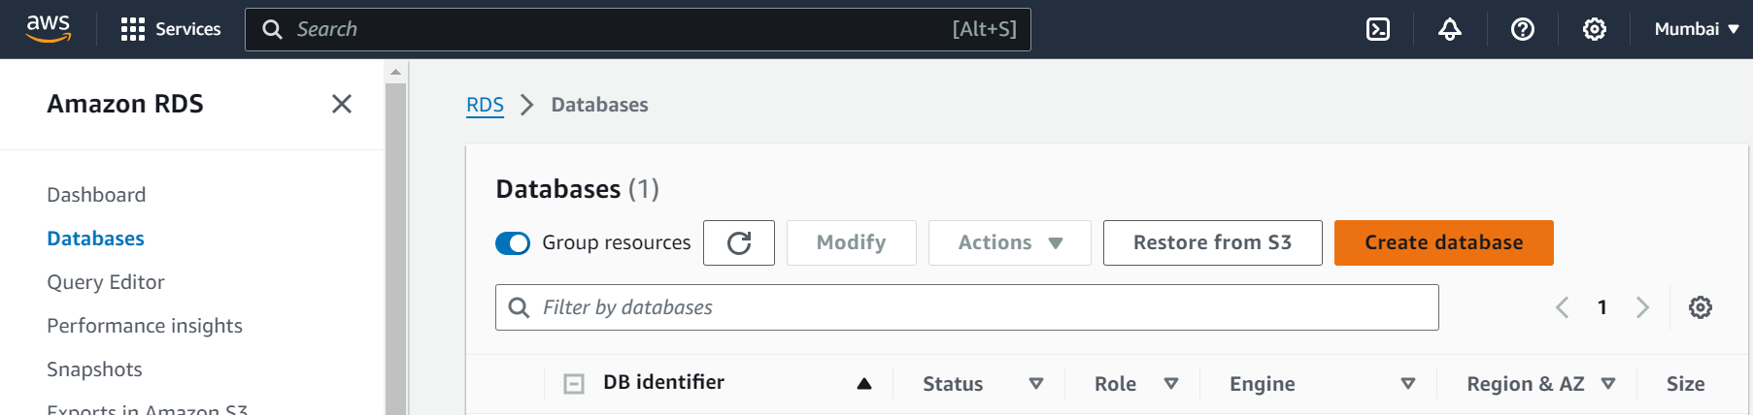

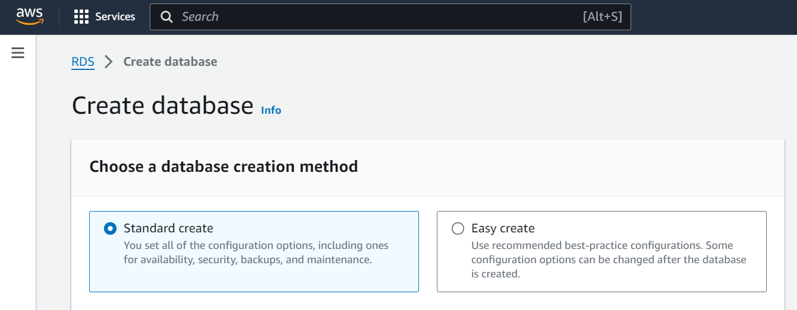

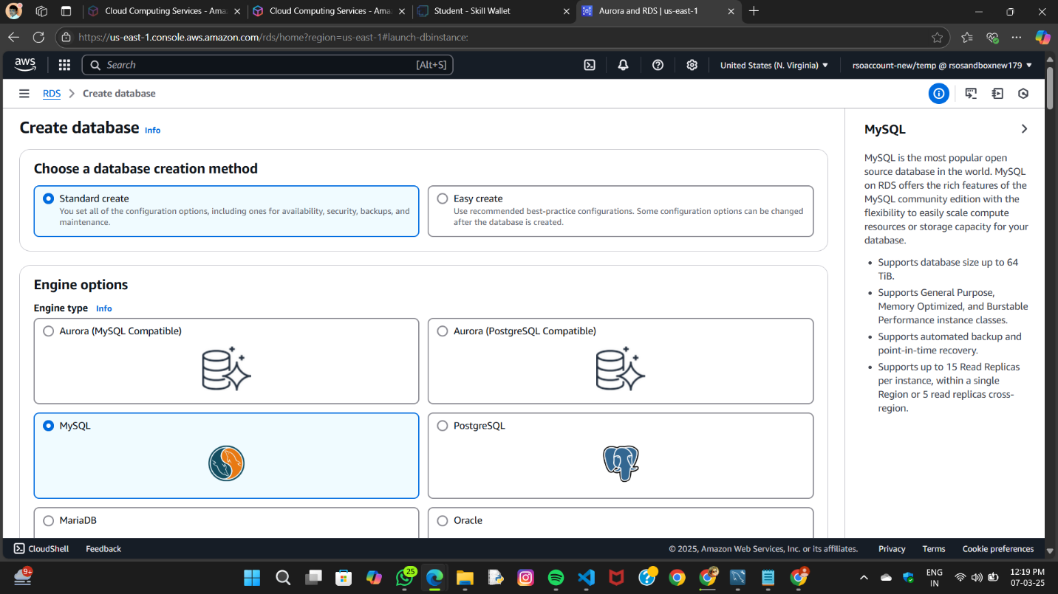

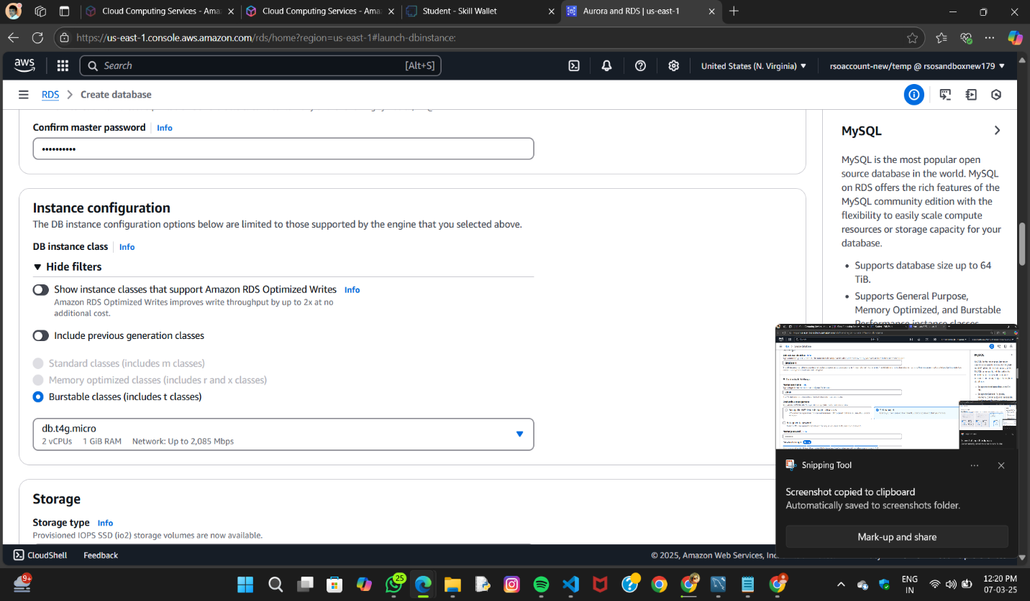

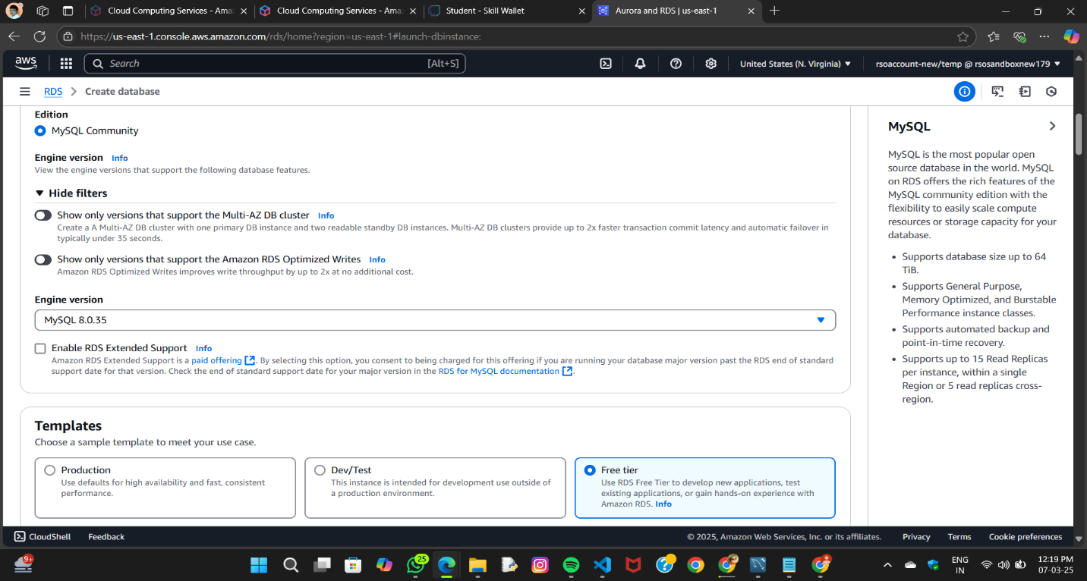

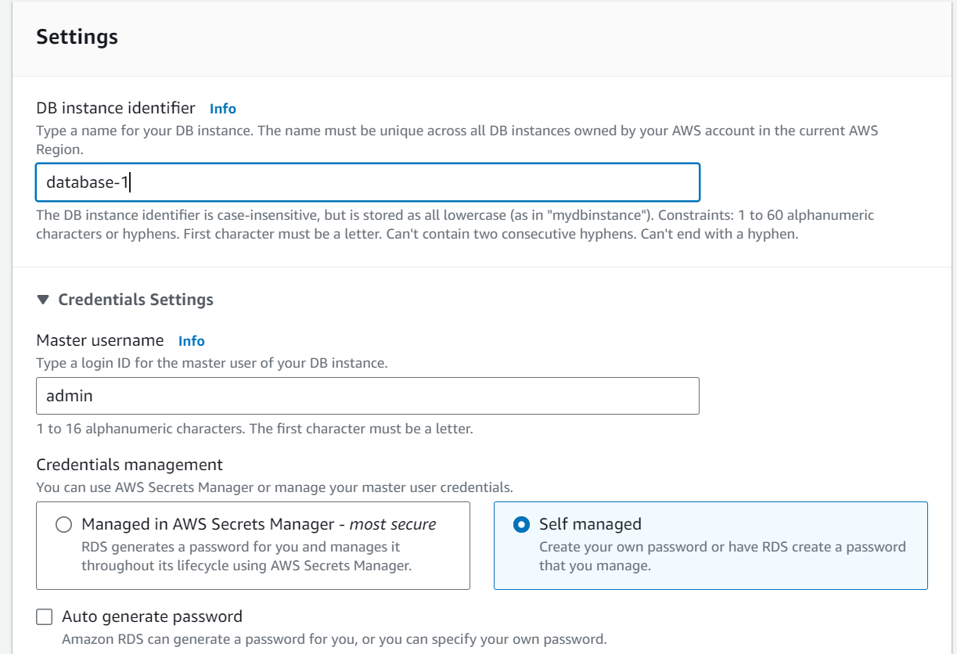

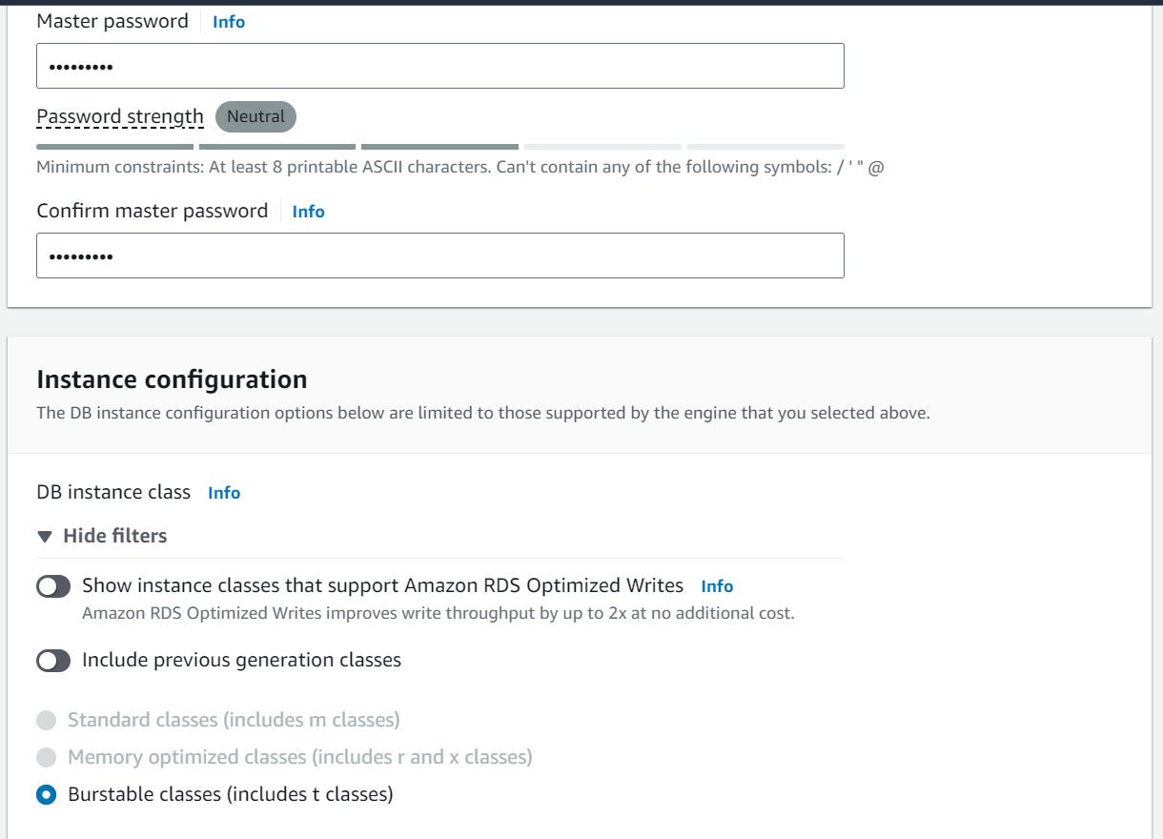

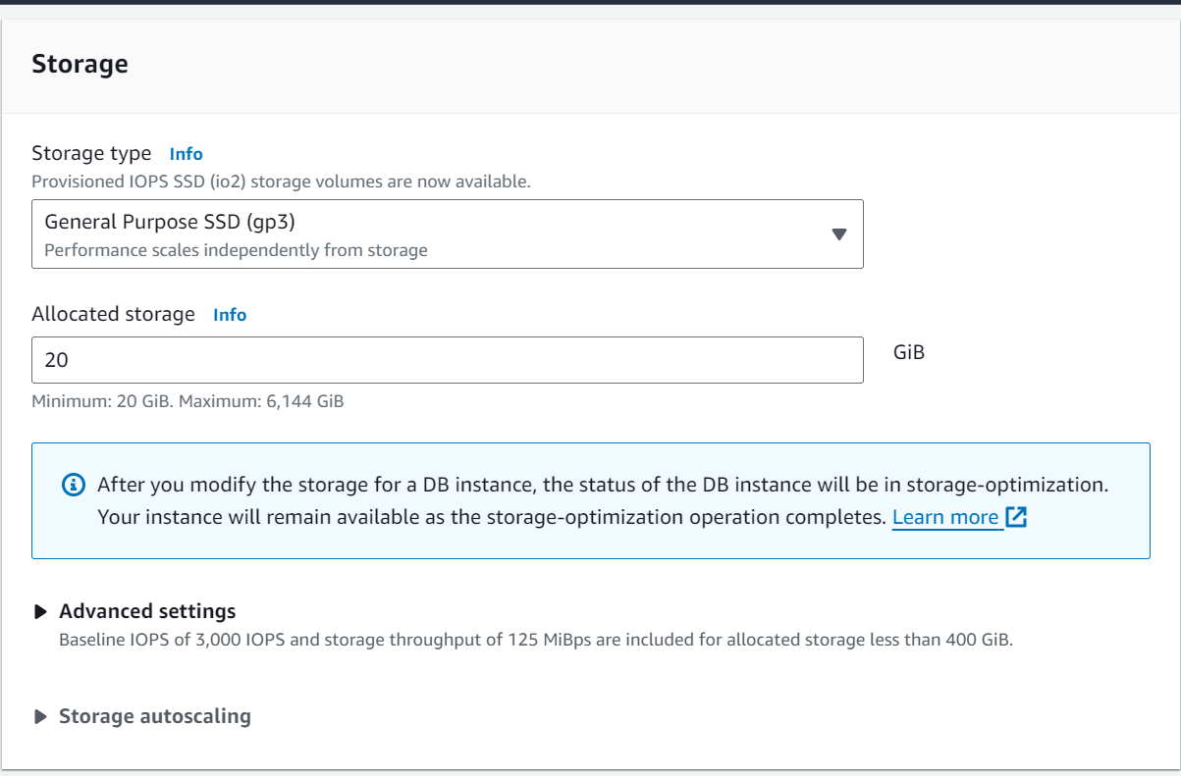

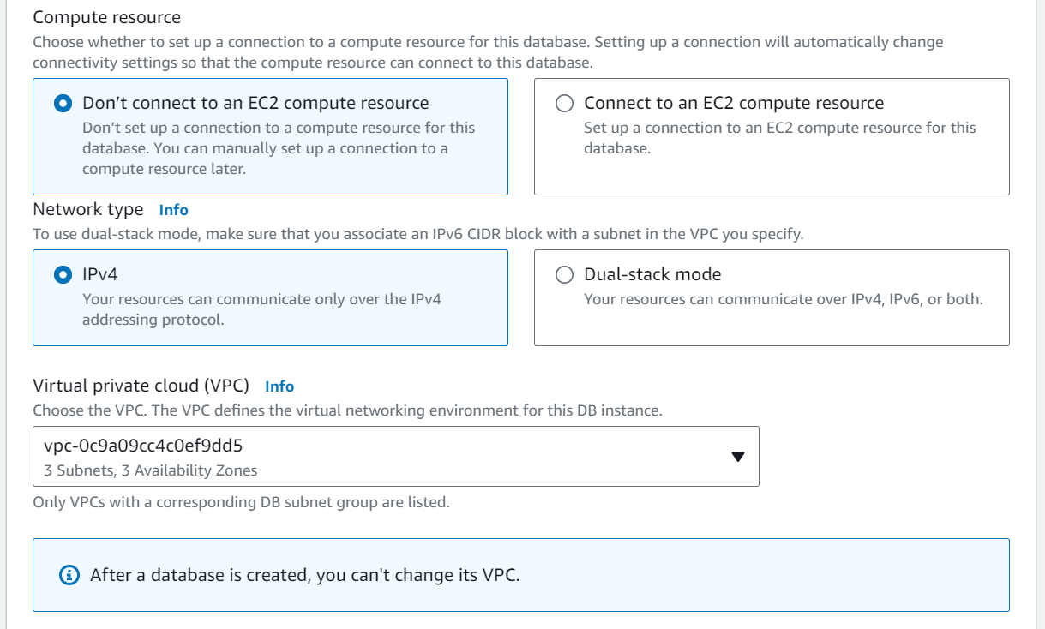

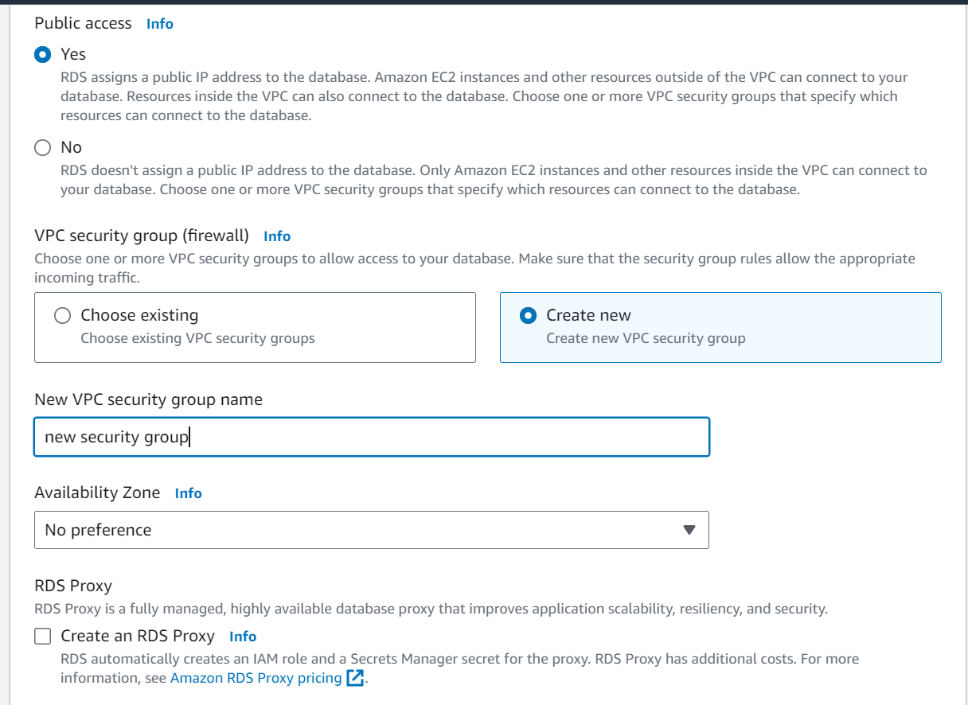

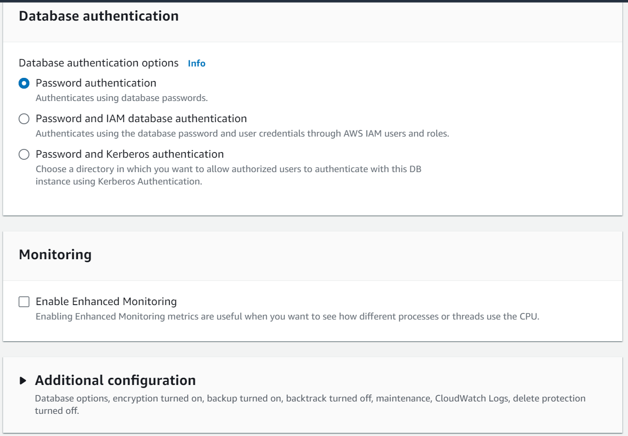

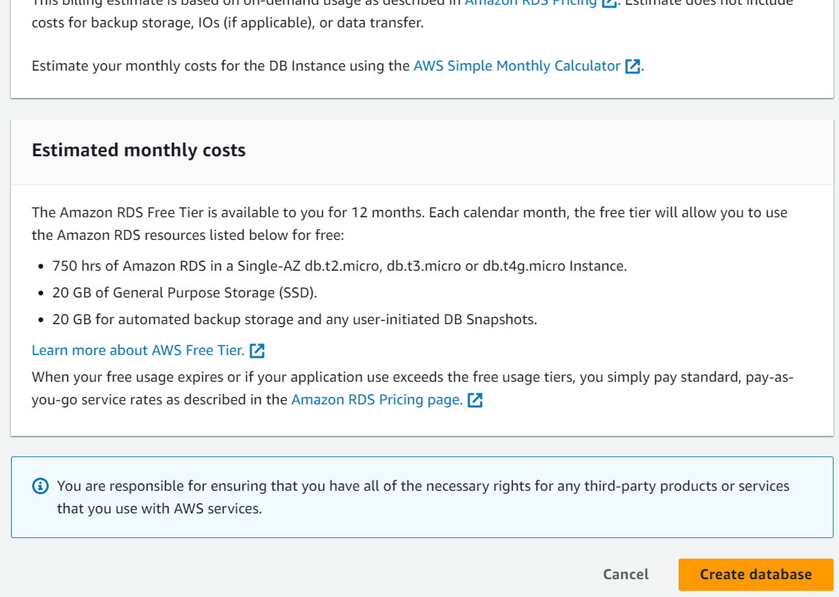

* **Activity 2.2: Configure Database Access**
  + Set up security groups, create database credentials, and configure access policies to ensure secure connectivity to the database.
* **Activity 2.3: Install MySQL Workbench**
  + Download and install MySQL Workbench on your local machine for database management.

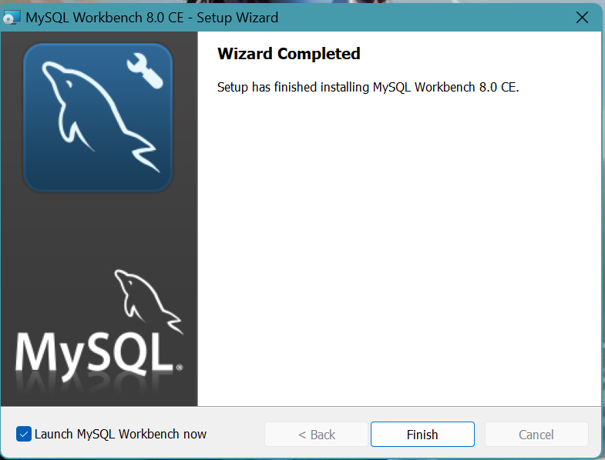

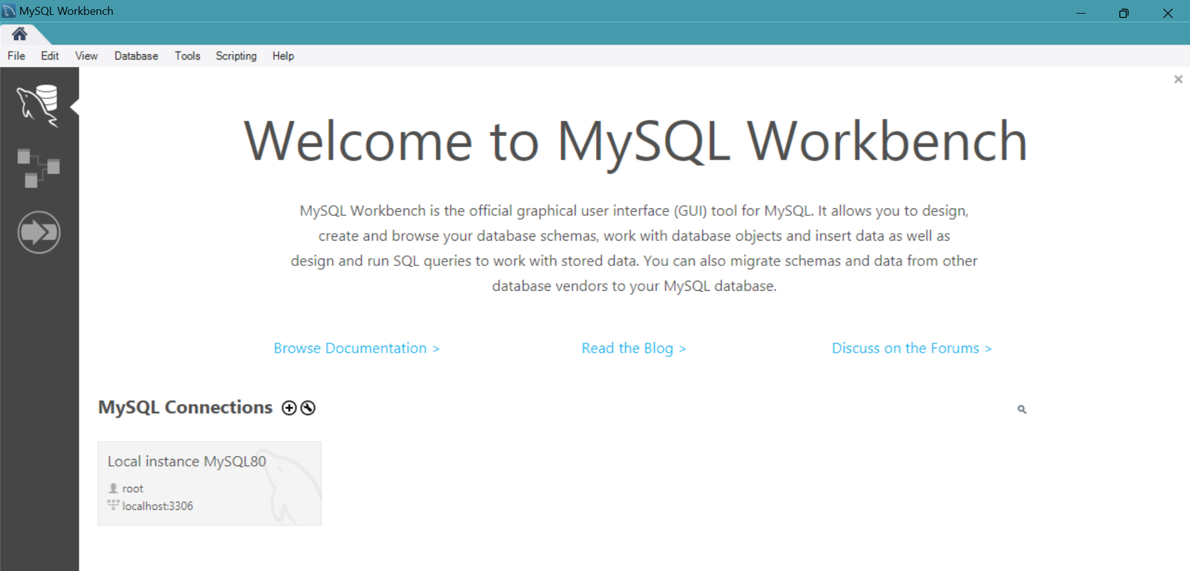

* + Connect to the RDS instance via MySQL Workbench using the endpoint and credentials from AW
  + 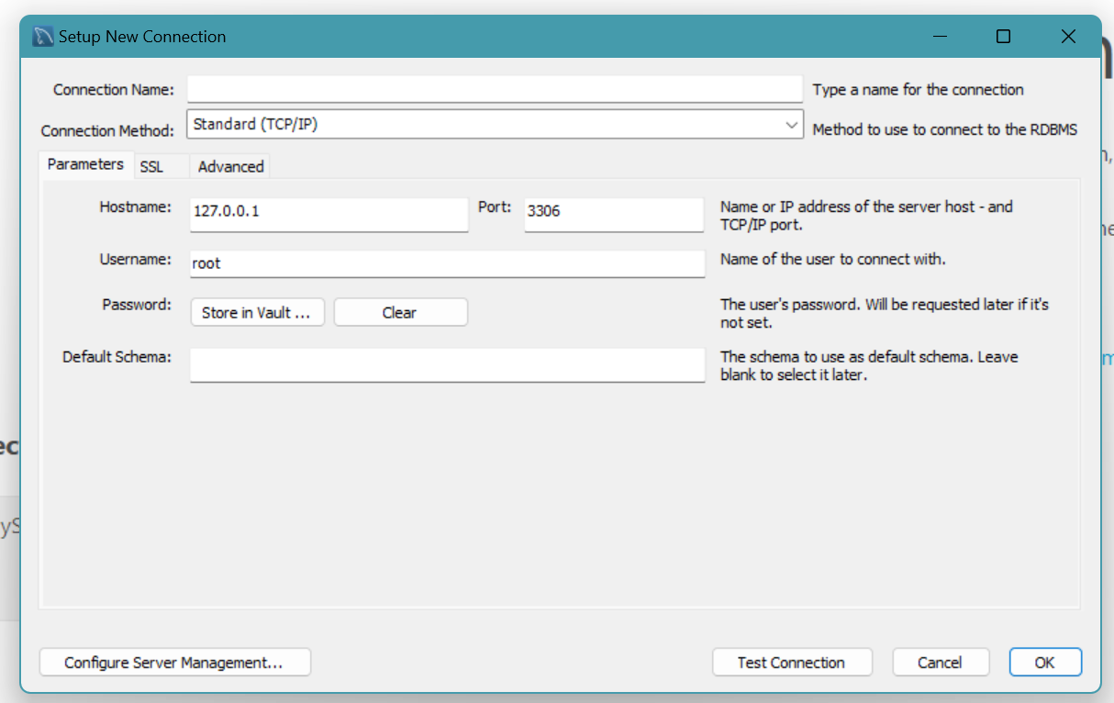
* Give a connection name.
* Copy the endpoint from the RDS database that is created in AWS and paste it in **Hostname.**
* Write the username and enter the password , then click on **Test Connection**.
* Once the connection is successful, you’ll be welcomed with this interface.

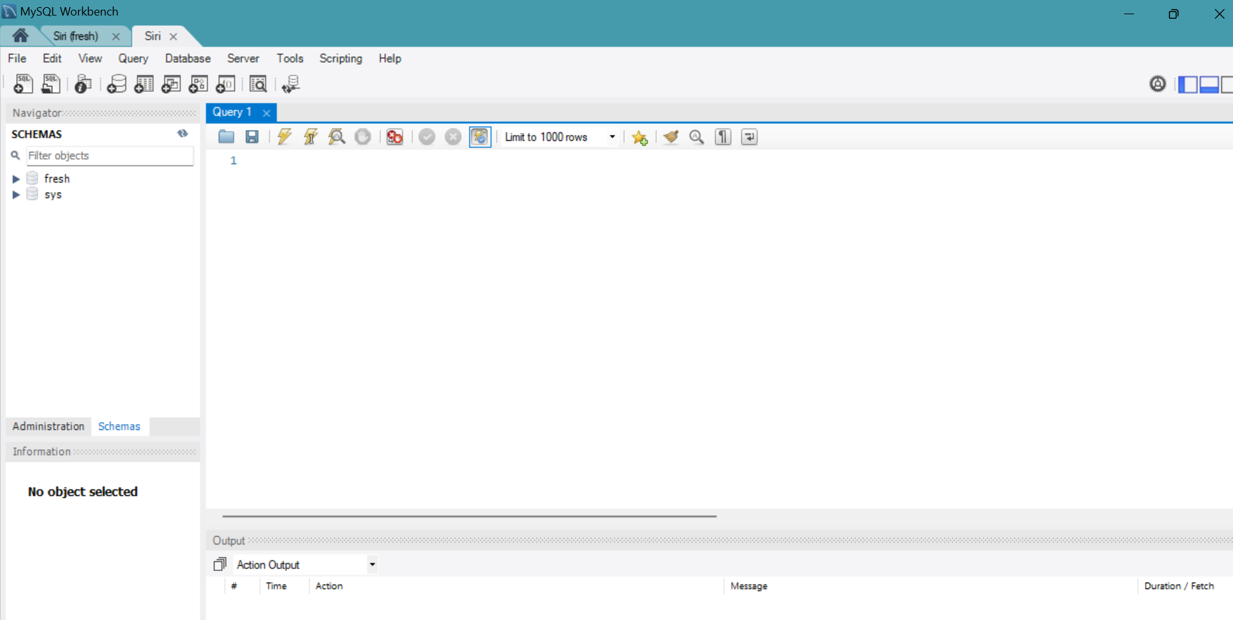

**Activity 2.4:** Create the Database and the tables which are required.

* **Create a basic database schema for an Blissful Adobes Hotel platform**

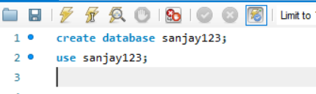

**users:**

* Stores user information such as name, email, password, and mobile number.
* Each user has a unique ID (id), which serves as the primary key.
* The email column is unique to ensure no duplicate accounts.
* The created_at column automatically records when the user was created.

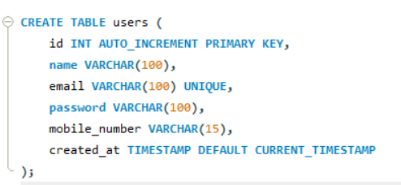

**bookings:**

* Contains booking details, including the user ID (foreign key referencing the users table), room type, number of people, check-in/check-out dates, special requests, payment mode, and total price.
* Each booking is assigned a unique identifier (id), which is the primary key.
* The user_id column links to the users table, establishing a relationship between bookings and the corresponding user.
* The created_at column automatically logs when the booking was made.

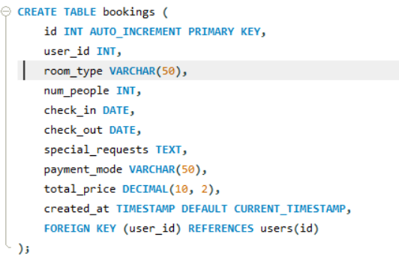

### Data Operations:

**1. Data Retrieval**: We retrieved data from each table to view the stored information, including user details, available items, and orders.

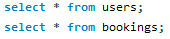

**Milestone 3: Frontend Development and Application Setup**

* **Activity 3.1: Build the Frontend**
  + Develop HTML, CSS, and Python-based Flask application files for Blissful Adobes Hotel’s frontend interface.

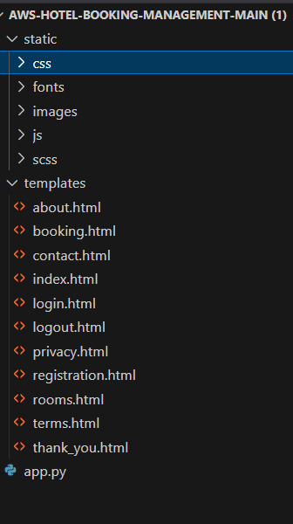

* **Activity 3.2: Integrate Application with RDS**
  + Connect app.py (Flask application) to the MySQL RDS database by configuring database connection settings and verifying connectivity.

**Description of the code :**

1. **Flask App Initialization**: Initializes a Flask application with secret key for sessions.

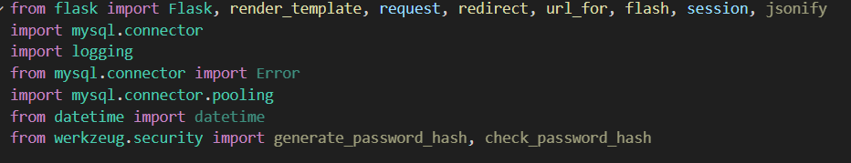

1. **Database Configuration**: Configures MySQL RDS with connection pooling for efficient database access.

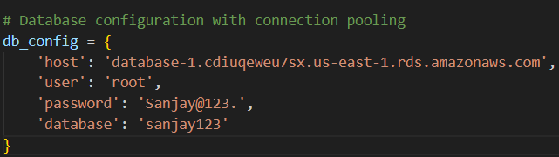

1. **Connection Pool**: Uses MySQL connection pooling to handle multiple database connections.

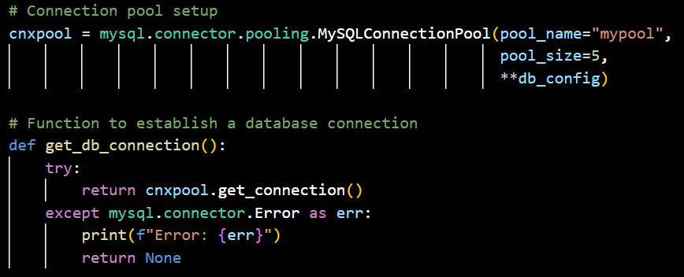

1. **Home Route**: Renders the home page template when the root URL is accessed.

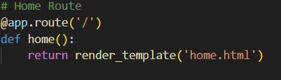

1. **Register Route (GET/POST)**: Handles user registration, inserts user data into the database.

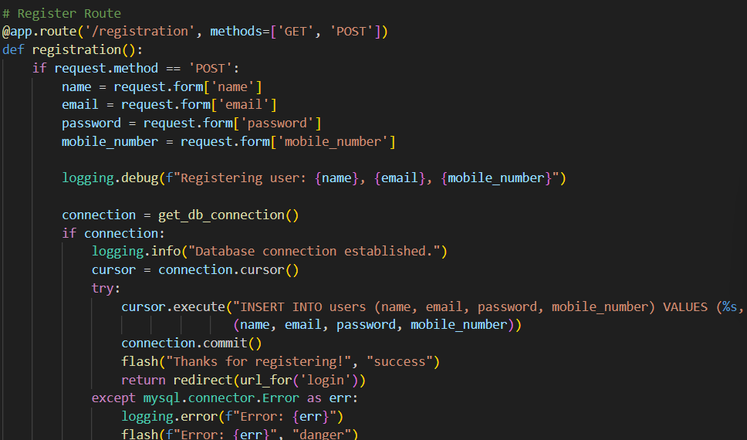

1. **Login Route (GET/POST)**: Authenticates user with email and password, creates session on success.

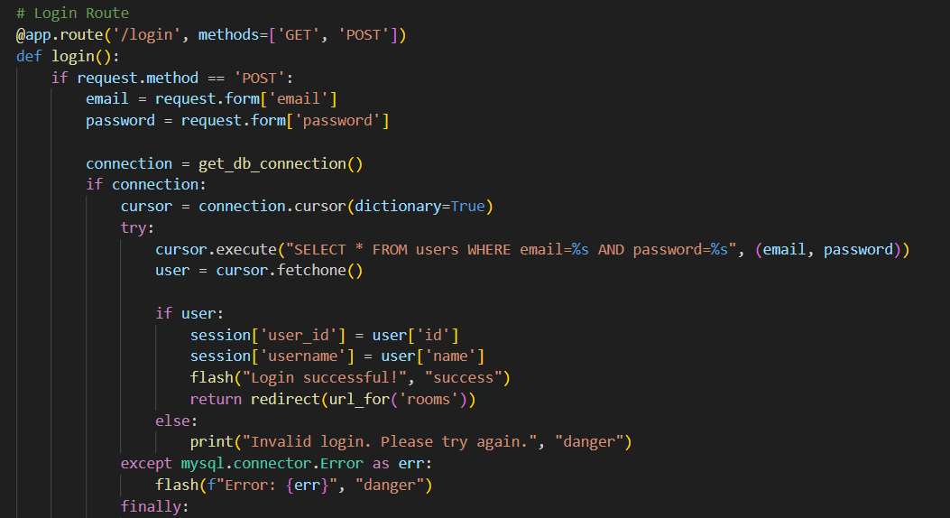

1. **Check_rooms Route**: Renders the check_rooms page, showing available room types to logged-in users.

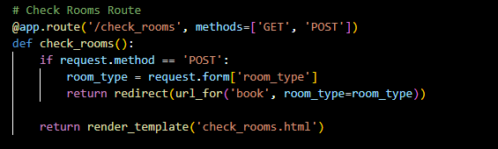

1. **Bookings Page**: Adds selected room type, to the user's booking details.

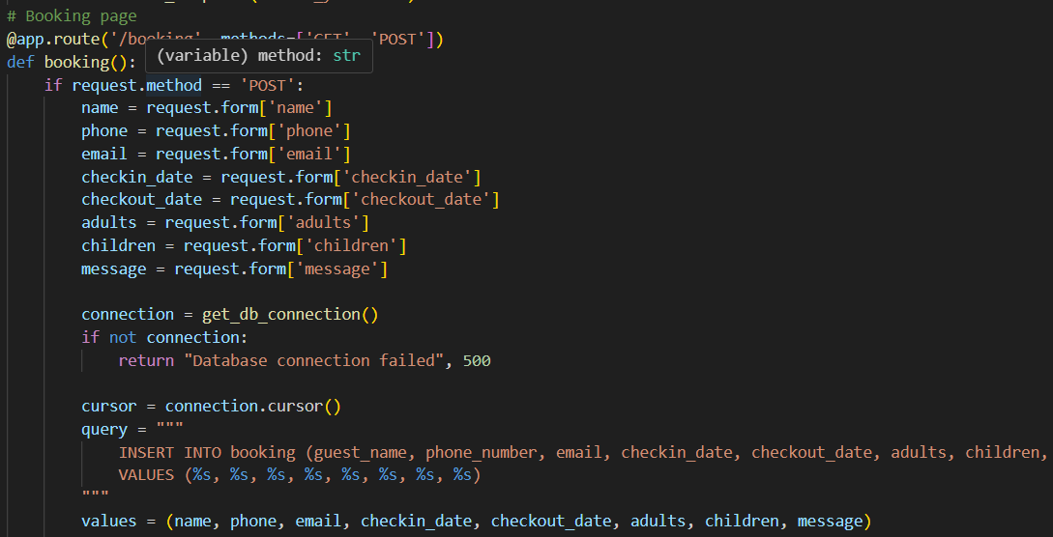

1. **Thank you route**: Shows the message “Thanks for Booking!” and redirects to the home page.

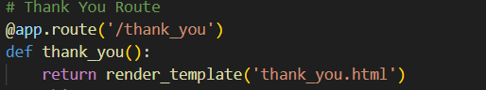

1. **My_bookings.html:** Shows all the bookings in the user dashboards.

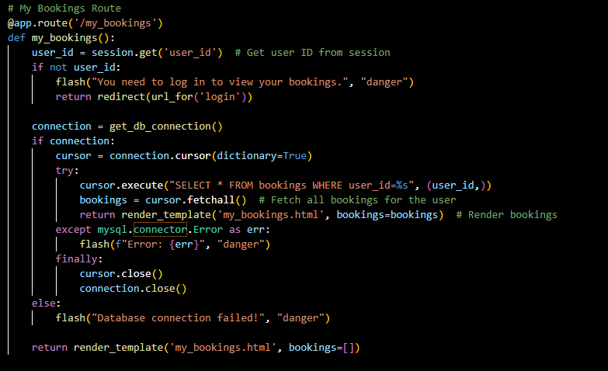

1. **Database Queries**: Uses SQL queries to interact with MySQL RDS for room availability, bookings, and customer data.
2. **Session Management**: Uses Flask sessions to store user preferences and booking details for seamless navigation.
3. **Flash Messages**: Provides user feedback through flash messages for login, registration, booking confirmation, and updates.
4. **Room Data Fetching**: Retrieves room types, prices, and availability from the database to display on the booking interface.

**Milestone 4: EC2 Instance Setup**

* **Activity 4.1: Launch EC2 Instance**
  + Choose a Linux-based EC2 instance from the AWS Console to host the hotel booking application.

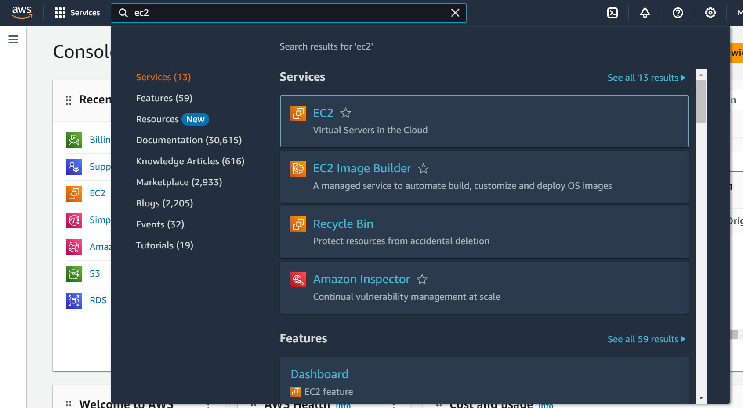

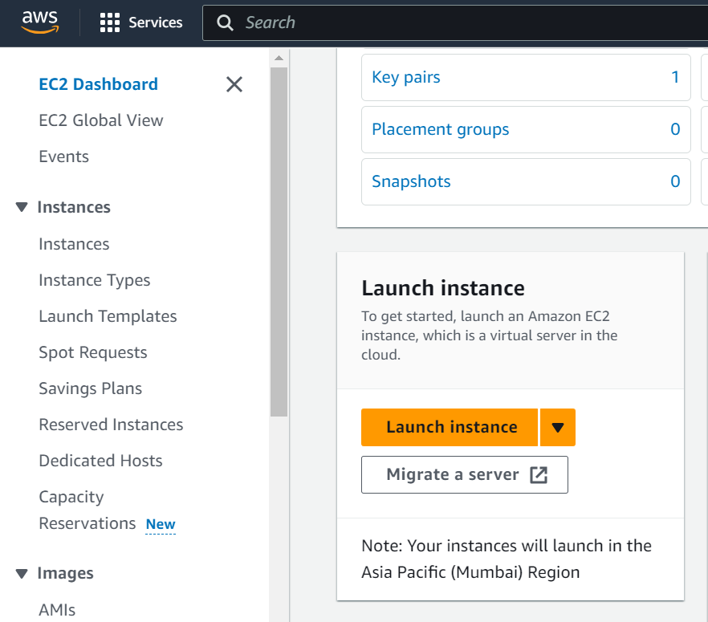

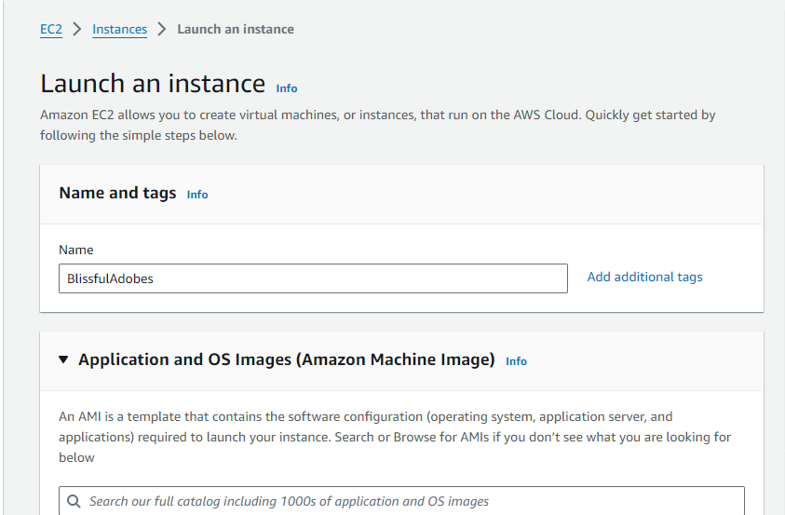

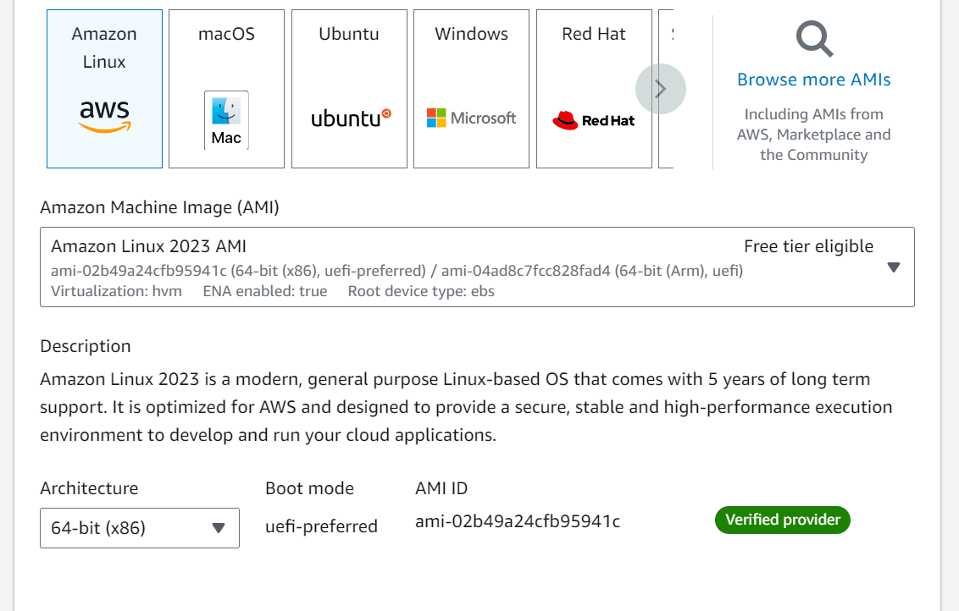

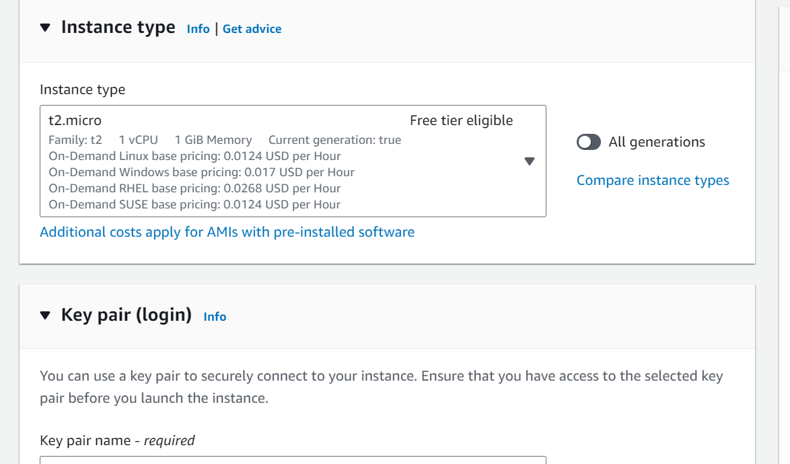

* **Activity 4.2: Configure Network Settings**
  + Set up the security group to allow HTTP, HTTPS, and SSH traffic.

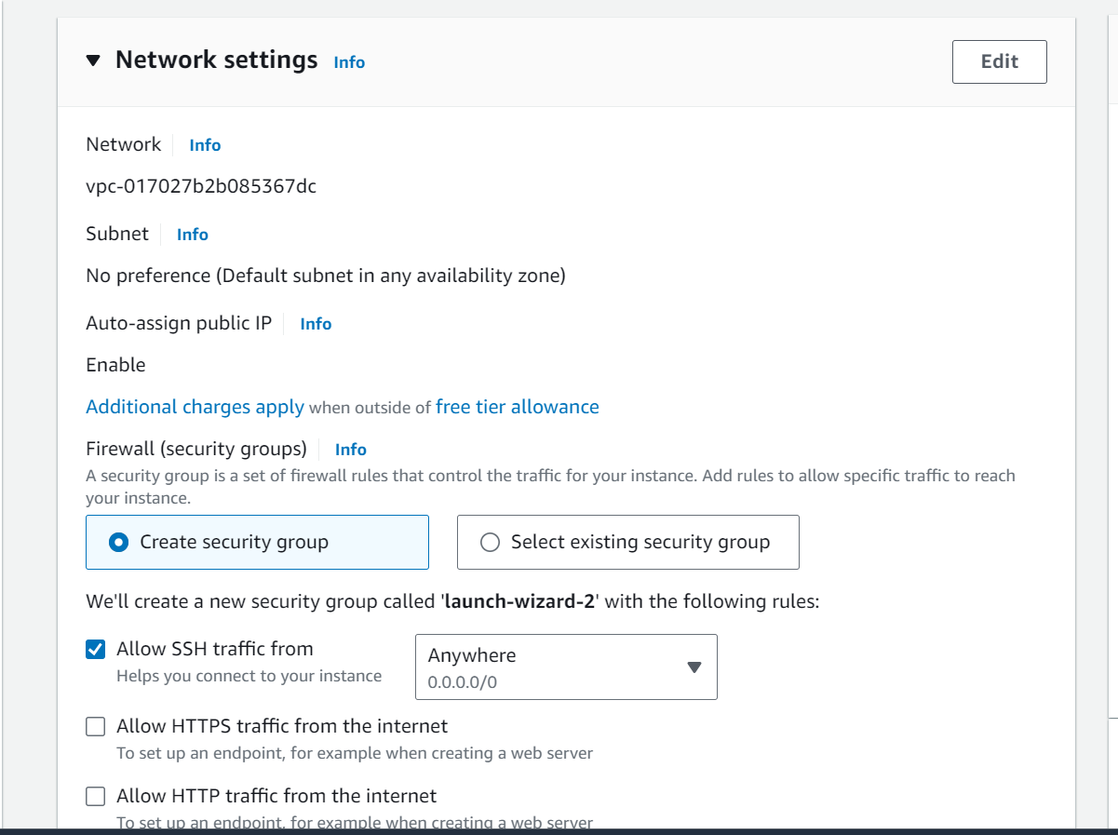

* + Create and download the key pair for SSH access.

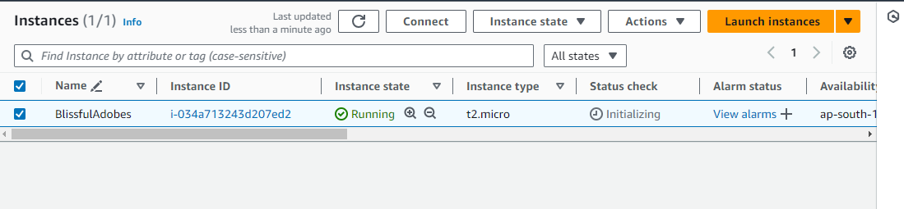

**Setting up Inbound and Outbound rules**

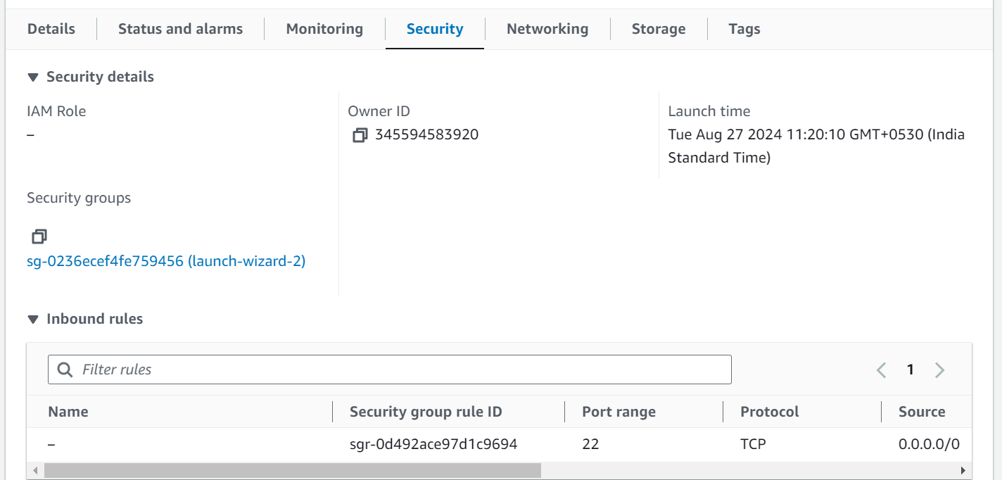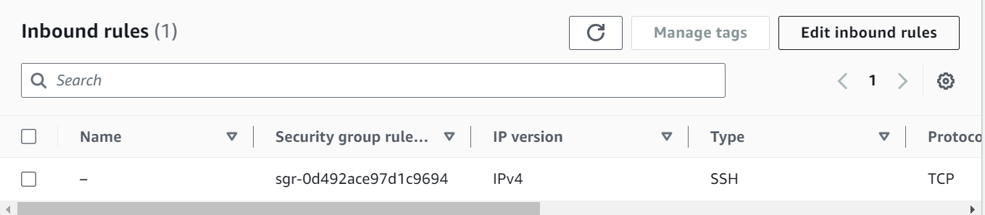

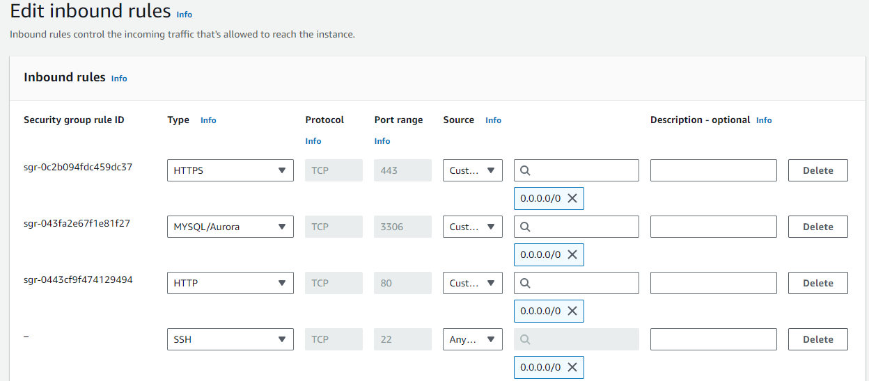

* Add Type : HTTP > Source : Anywhere
* Add Type : HTTPS > Source : Anywhere

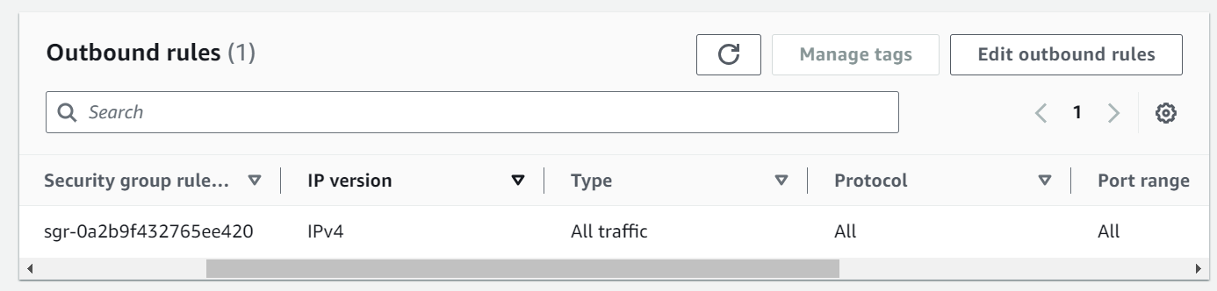

**Milestone 5: Deployment on EC2**

**Activity 5.1: Deploy to EC2**

1. Connect EC2 terminal.
2. Set up any necessary environment variables, including database connection strings.
3. Configure the web server to serve your application.
4. Start your application and ensure it's accessible via the EC2 instance's public IP or domain.

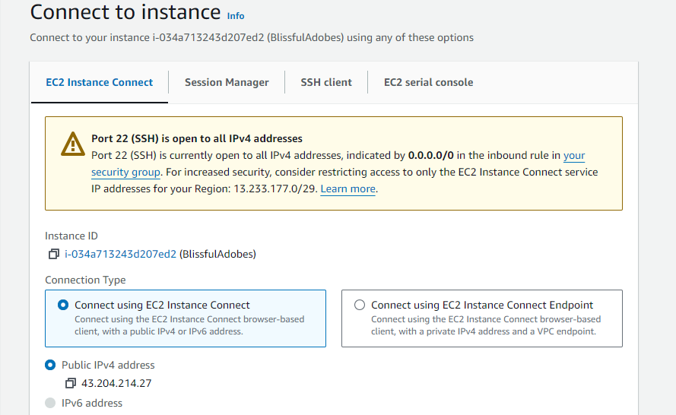

1. Run the below commands on ec2 terminal
2. sudo yum update -y
3. sudo yum install python3 -y
4. sudo pip3 install virtualenv
5. python3 -m venv venv
6. source venv/bin/activate
7. pip install flask
8. Connecting to github

### Step 1: Create a GitHub Repository

**Log in to GitHub**: Go to [GitHub](https://github.com/) and log in to your account.

* Create a **New Repository**
* Click on the **+** icon at the top-right corner and select **New repository**.

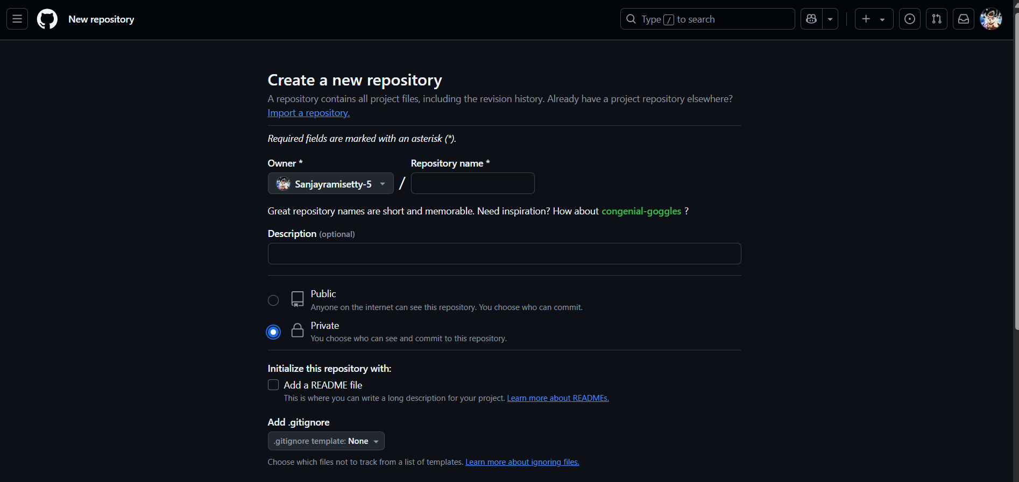

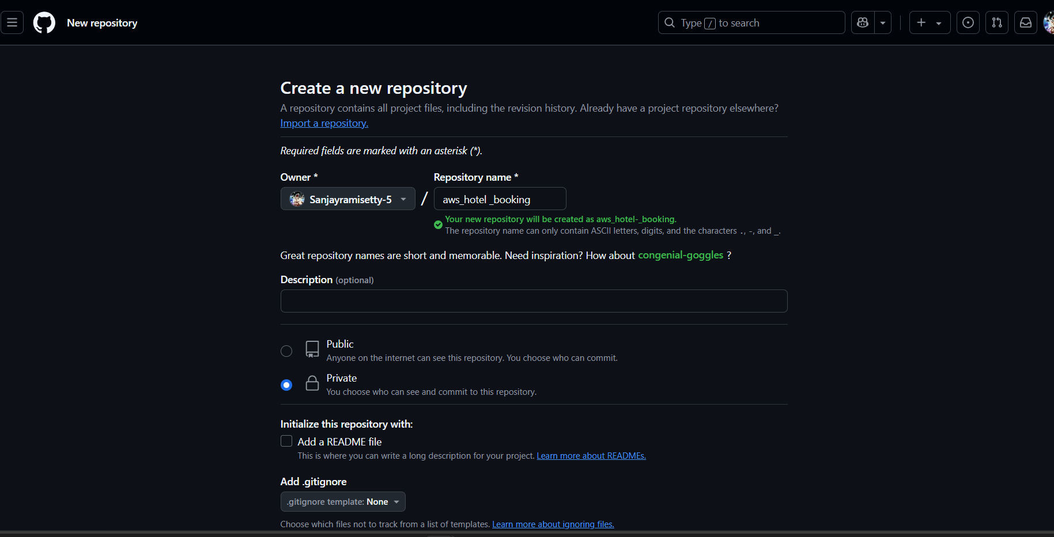

* Enter a **Repository name**.
* (Optional) Add a description, choose whether the repository is **Public** or **Private**.



* (Optional) You can initialize the repository with a README file, but it’s optional if you're uploading an existing folder.
* Click **Create repository**.

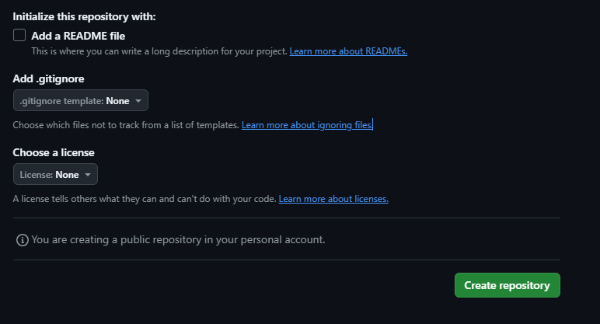

* Click on uploading an existing file

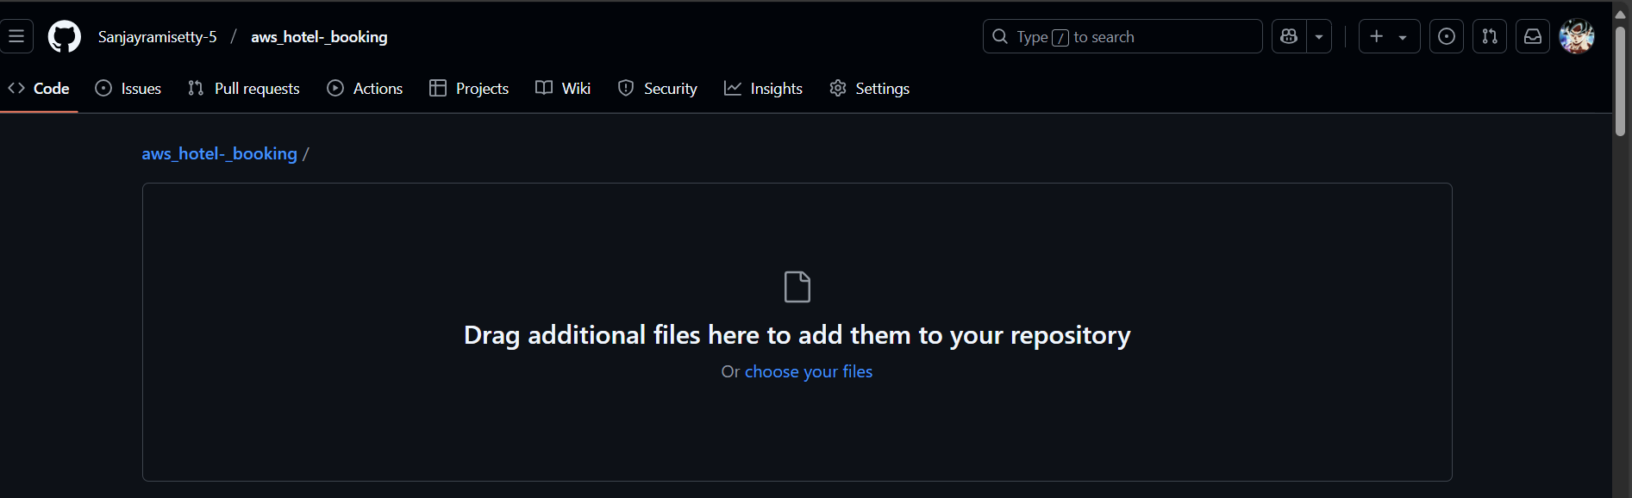

* Drag and drop your project folder and click on commit changes

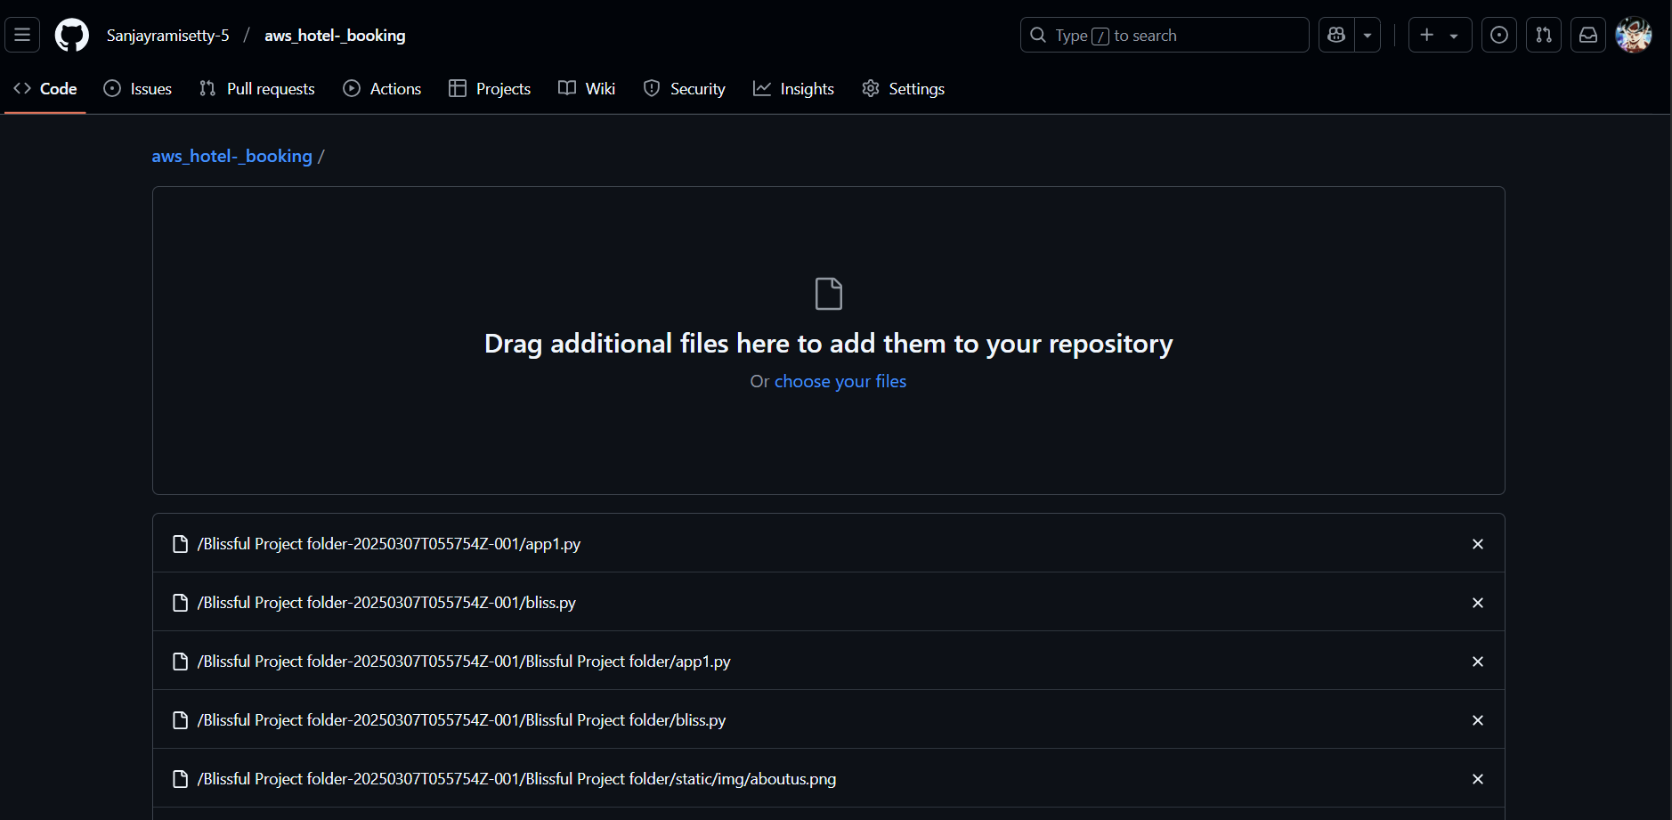

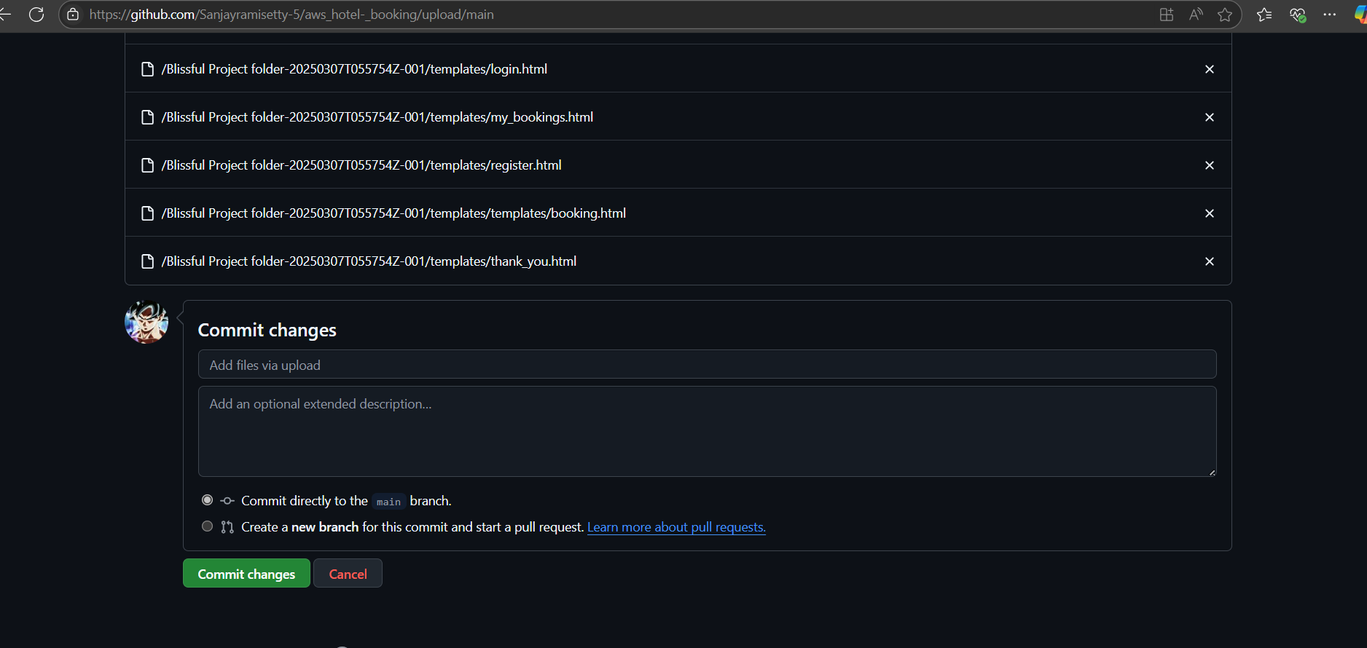

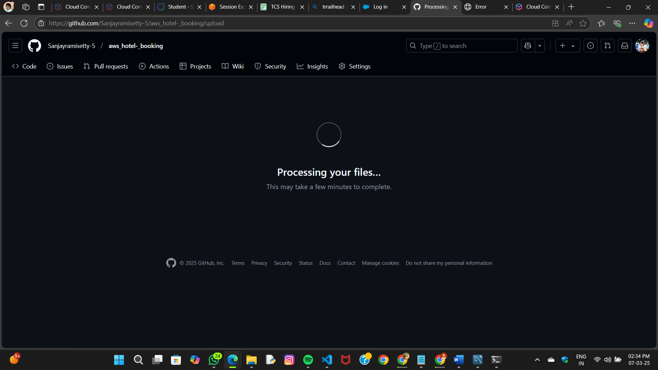

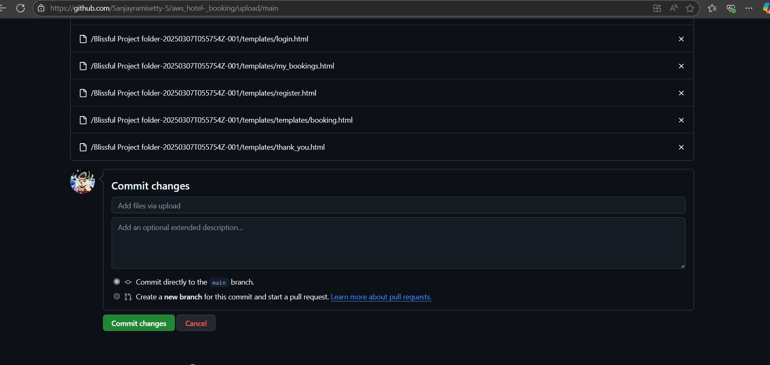

* After that, click on code to get github link

1. git clone https://github.com/Sanjayramisetty-5/AWS-Hotel-Booking-Management

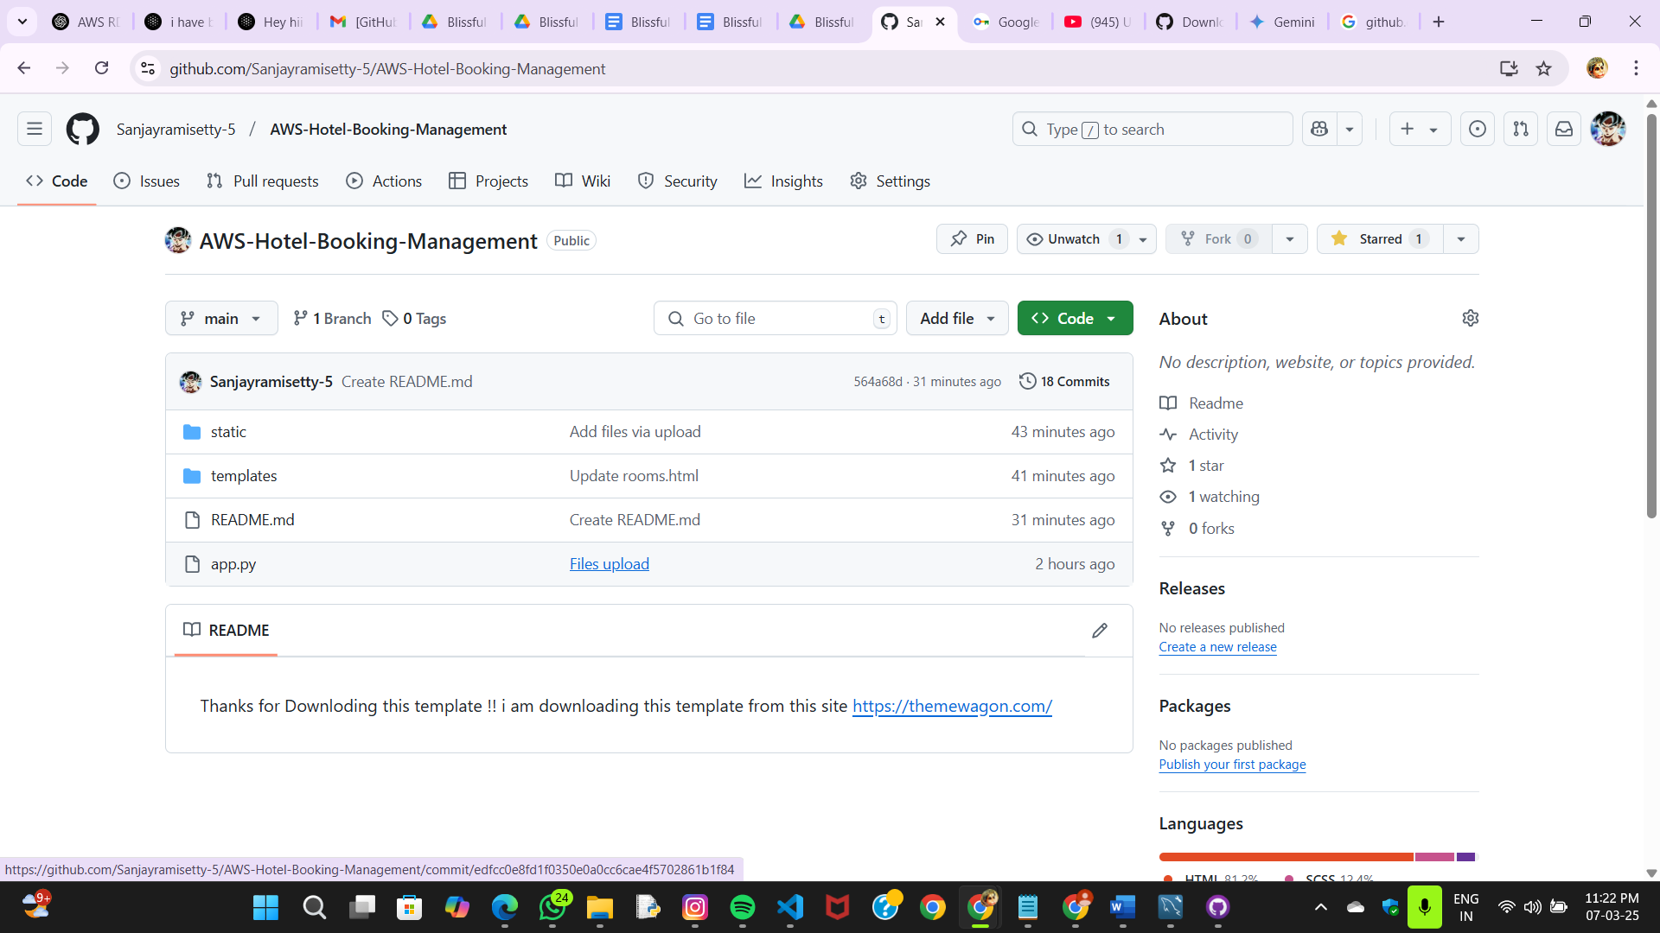

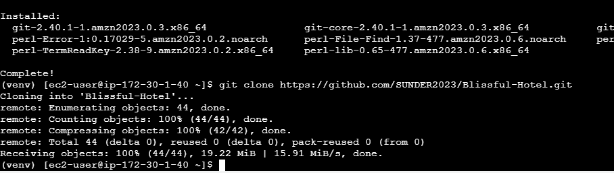

1. cd your-flask-app
2. python3 app.py

**Milestone 6: Testing and Deployment**

* **Activity 6.1: Functional Testing**
  + Test the bliss.py application for functionality, including database interactions and frontend features.
  + Run the Flask app **python3 app.py**
  + It will give you the link

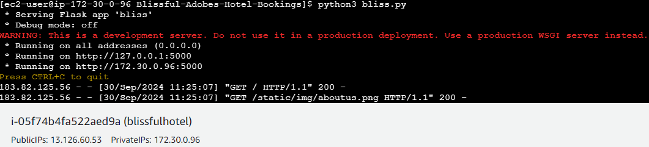

**Access the website through:  
 PublicIPs:** [**http:13.126.60.53:5000**](http://13.126.60.53:5000)

* **Activity 6.2: Deployment**
  + Deploy the application in a production environment, ensuring high availability and performance.

Click on the link above and it will take you to the webpage:

**Home:**

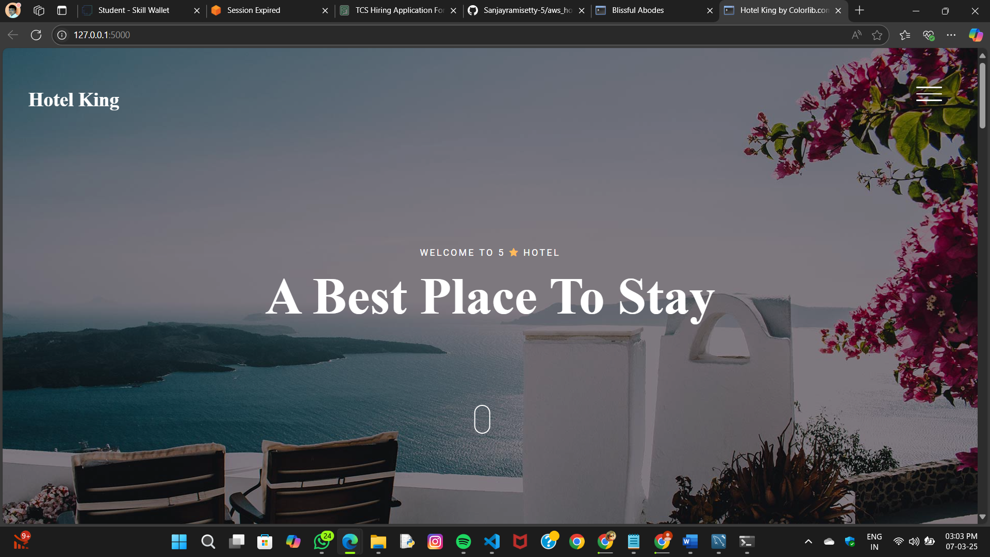

**Register:**



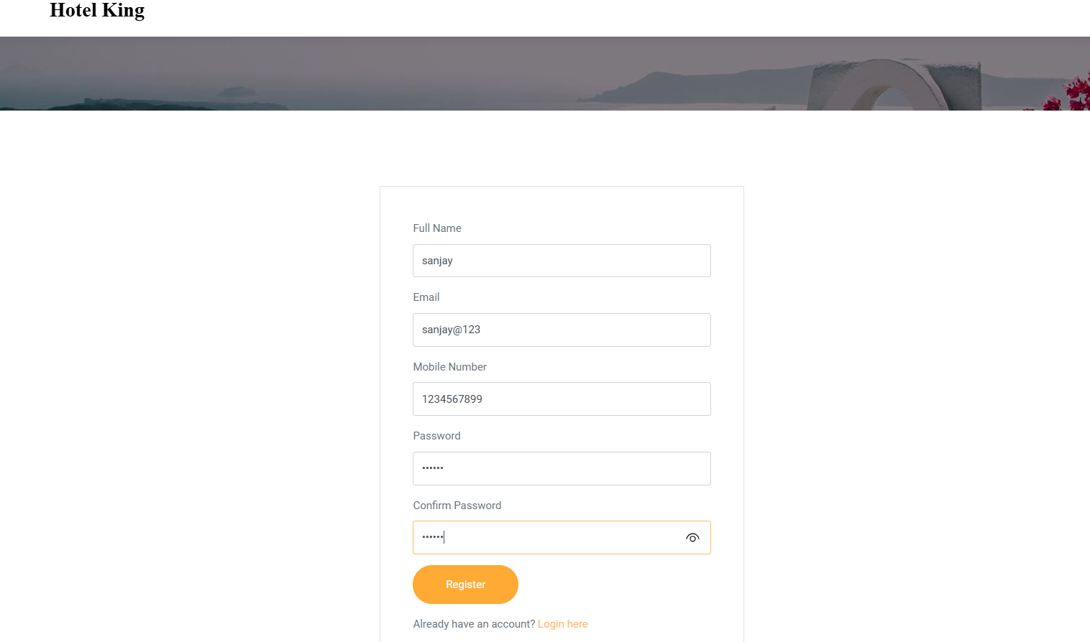

**Login:**



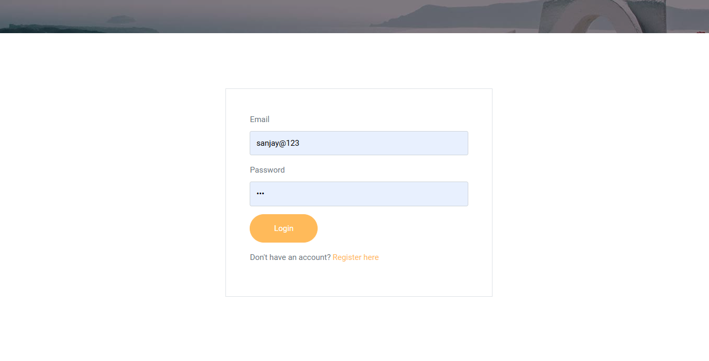

**Check Rooms:**





**Bookings:**



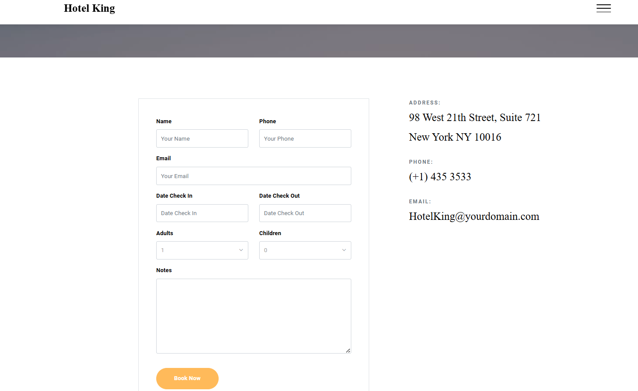

**Booking Confirmation:  
 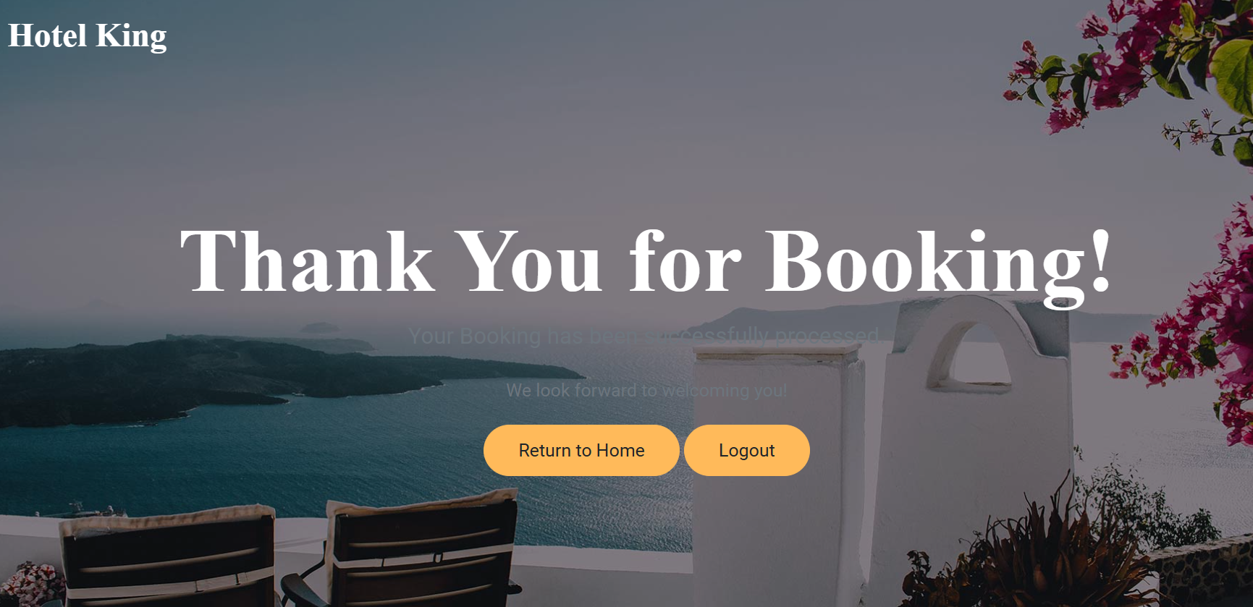**

**User booking Details:**

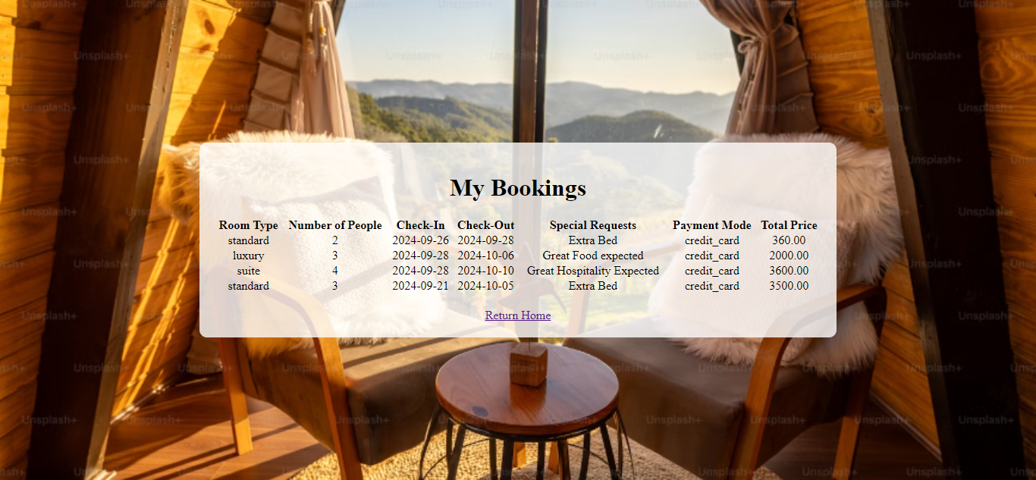

* **Activity 6.3: Check the updations in the mysql database.**

**MySql Database updations :**

1. **Users table :**

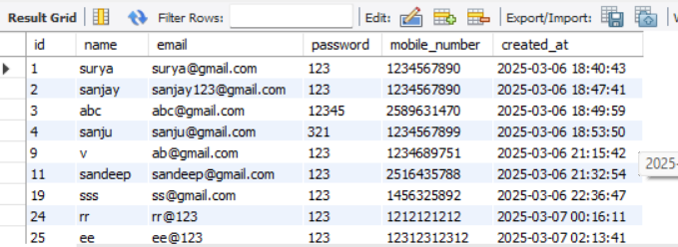

1. **Bookings table:**

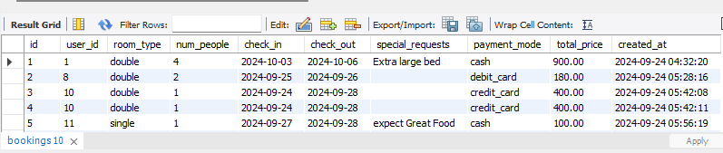

**Conclusion:**

The hotel booking project demonstrates the development of a user-friendly, dynamic, and scalable platform using AWS. By integrating Flask with MySQL RDS, it ensures efficient management of room availability, bookings, and customer data. The EC2 instance, along with MobaXterm, enables easy remote management and deployment of the application. From database setup to frontend development and seamless booking functionality, every stage was executed to ensure reliability and performance. AWS CloudWatch is used to monitor system performance, ensuring smooth operation. Overall, the project highlights how AWS services can support real-time, scalable hotel booking systems in practical scenarios.

Special thanks to our mentors:

1.Sunder sir

2.Siri mam

3.Surya Varma sir

4.Alekhya mam

5.Kusuma mam